**CSS (Grid)**

**Duration 4h (Totally 14)**

**Basic**

**1.Create the following using Grid**



**2.Create the following using Grid**

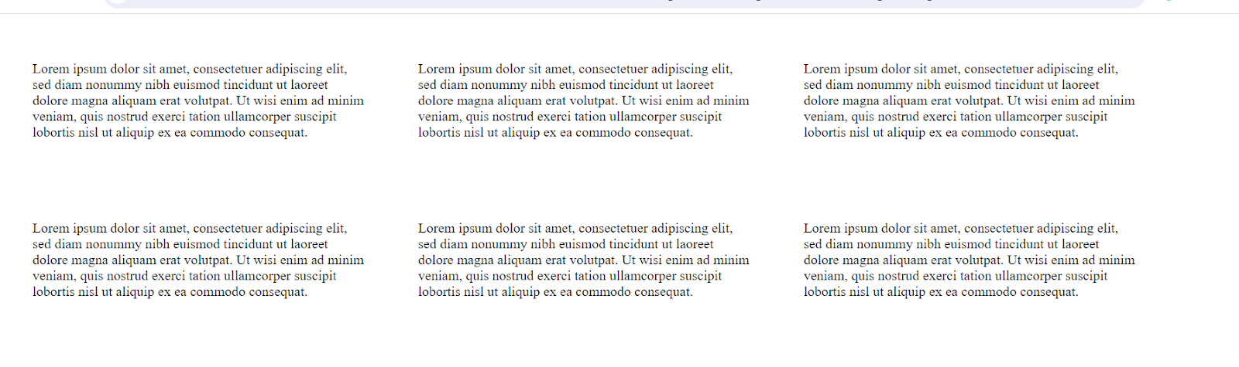

**3.Create the following using Grid**

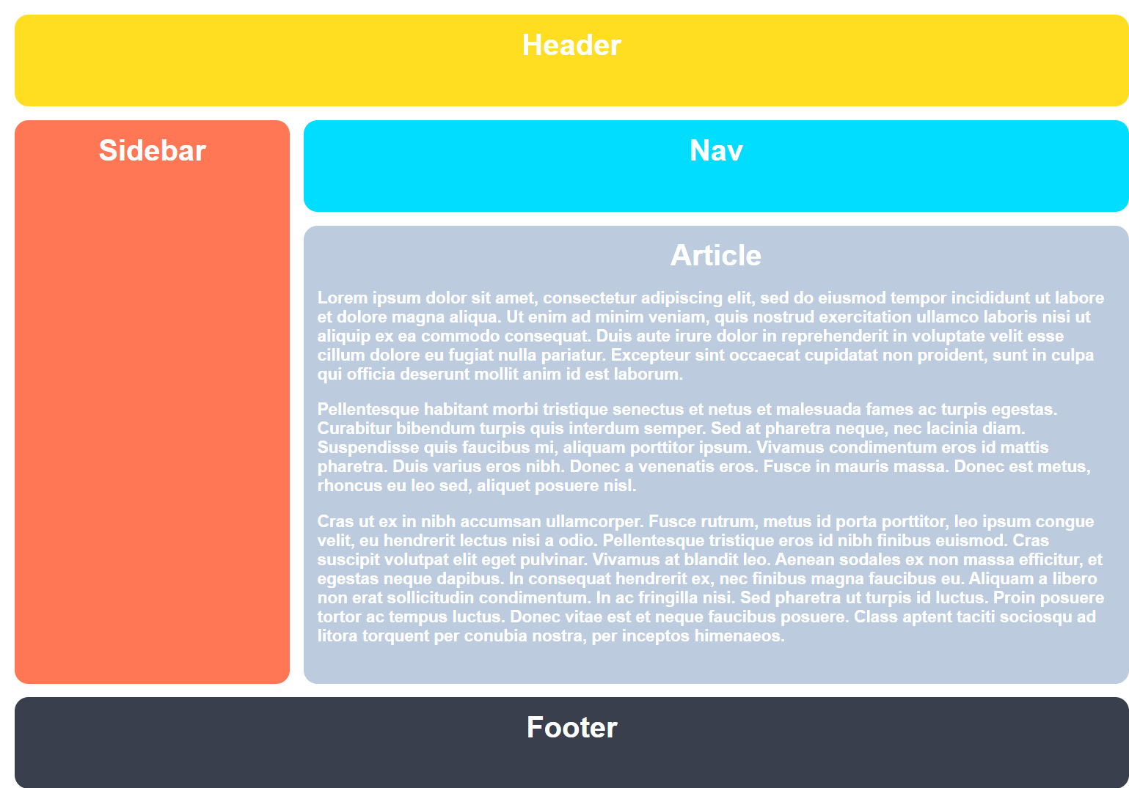

**4.Create the following using Grid**

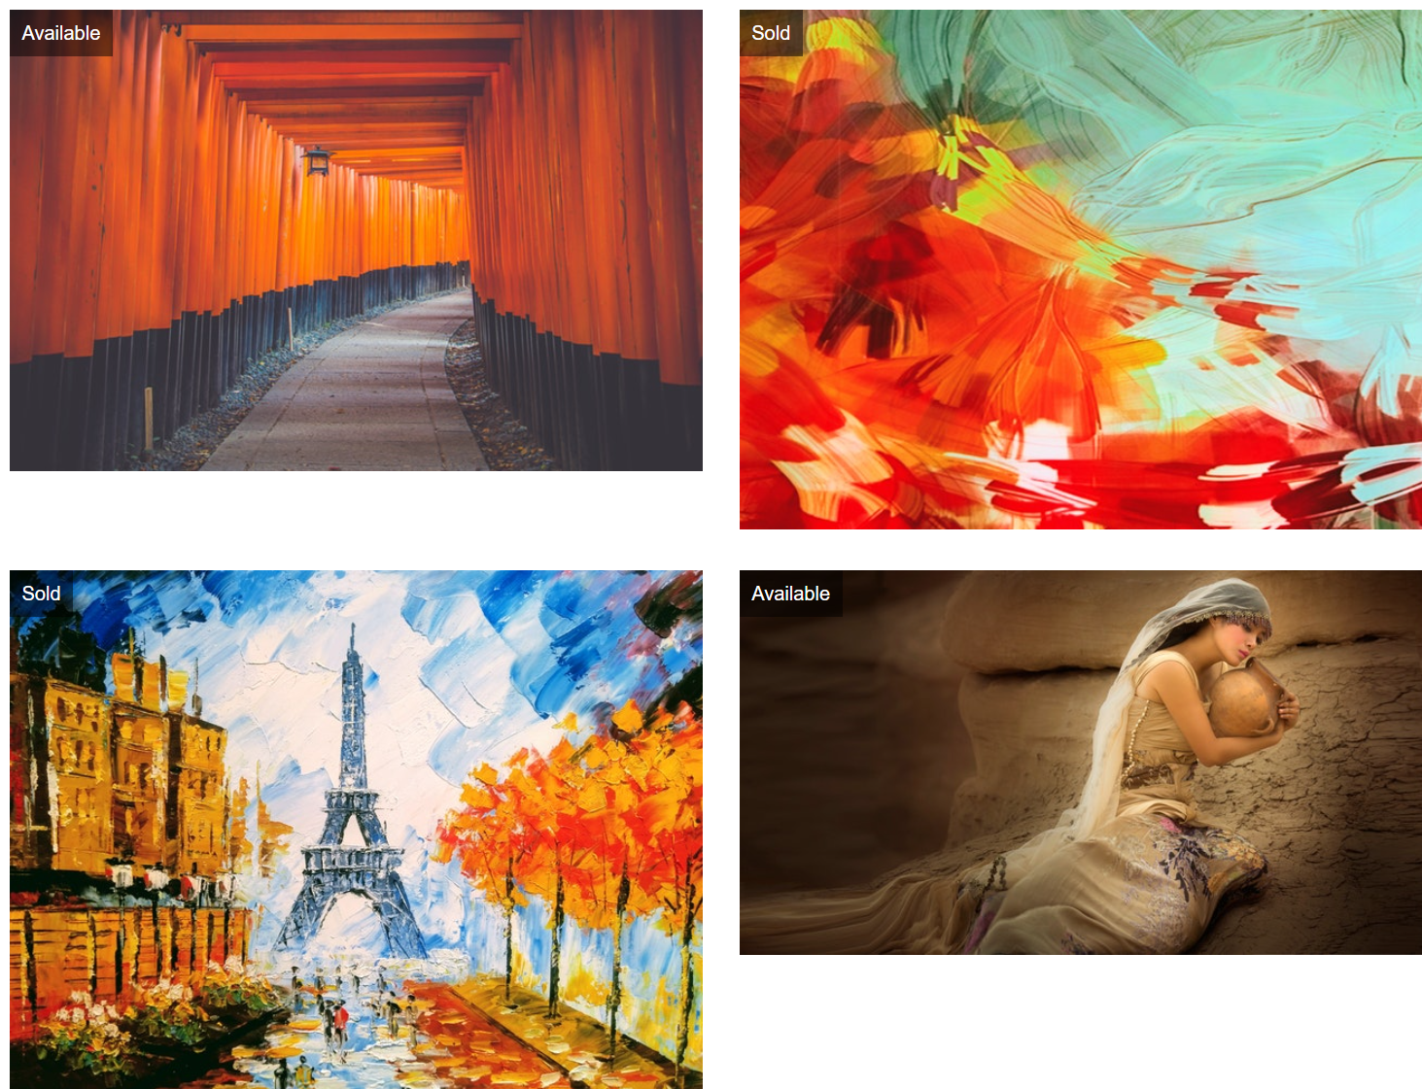

**Intermediate**

**5.Create the following(using Grid):**

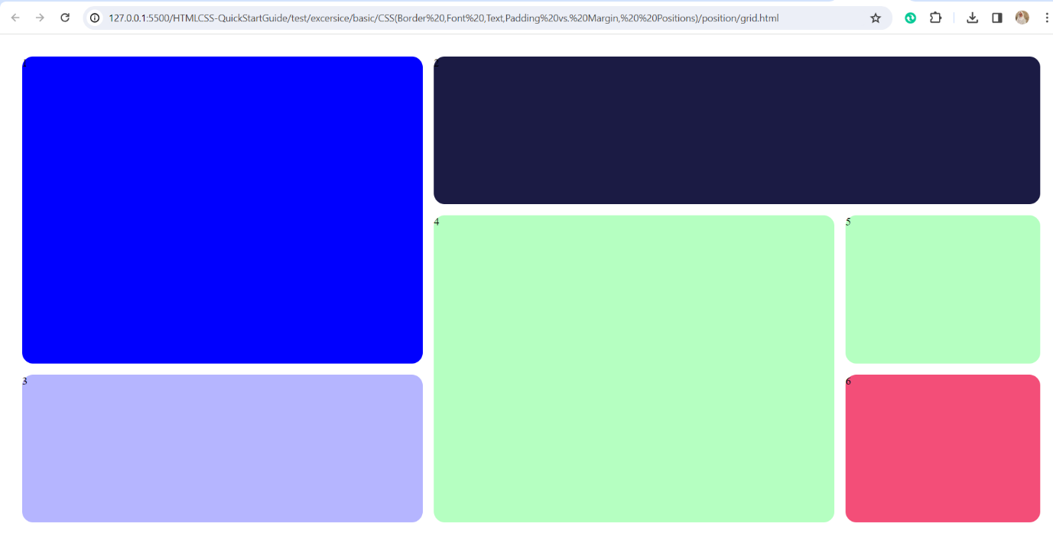

**6.Create the following(using Grid):**

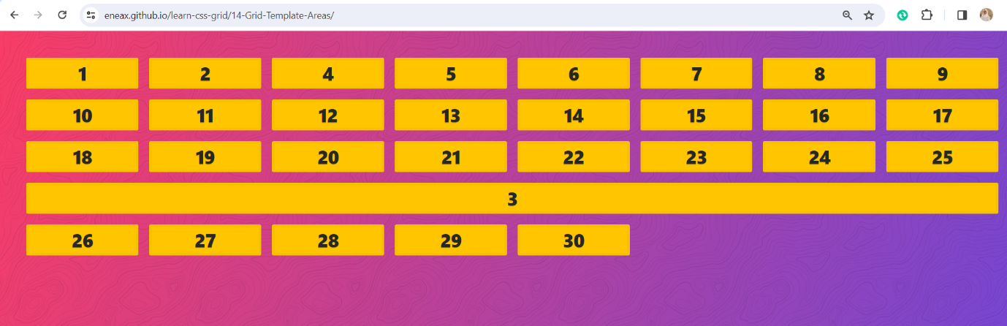

**7.Create the following(using Grid):**

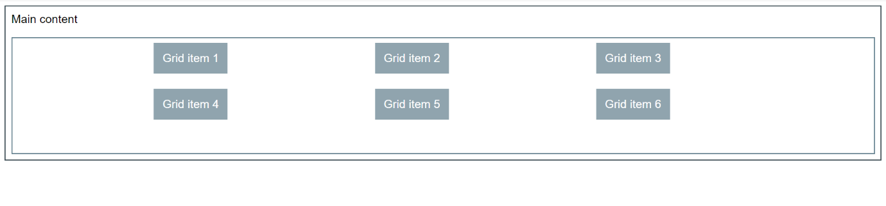

**8.Create the following(using Grid):**

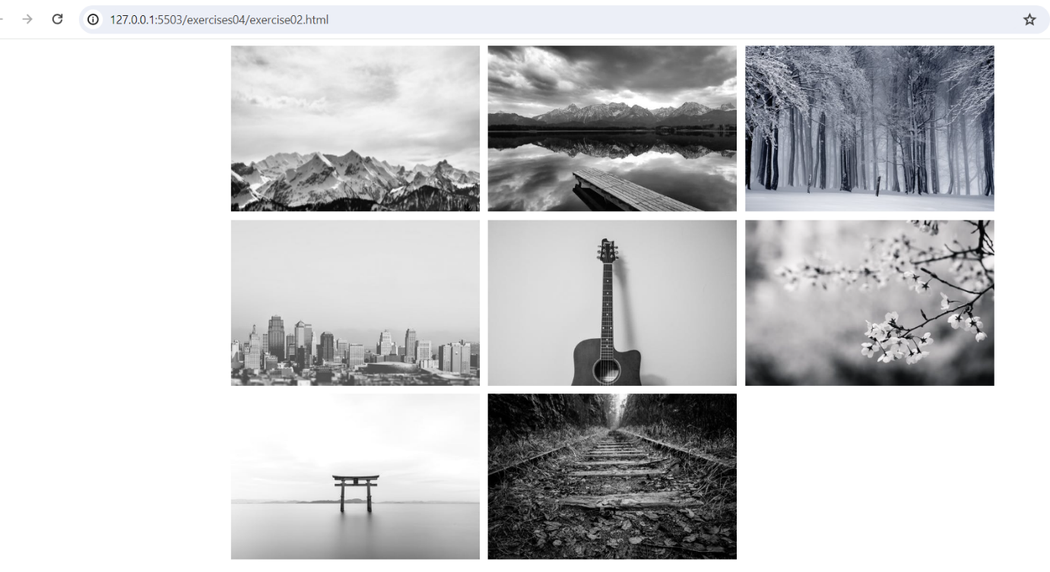

**9.Create the following(using Grid):**

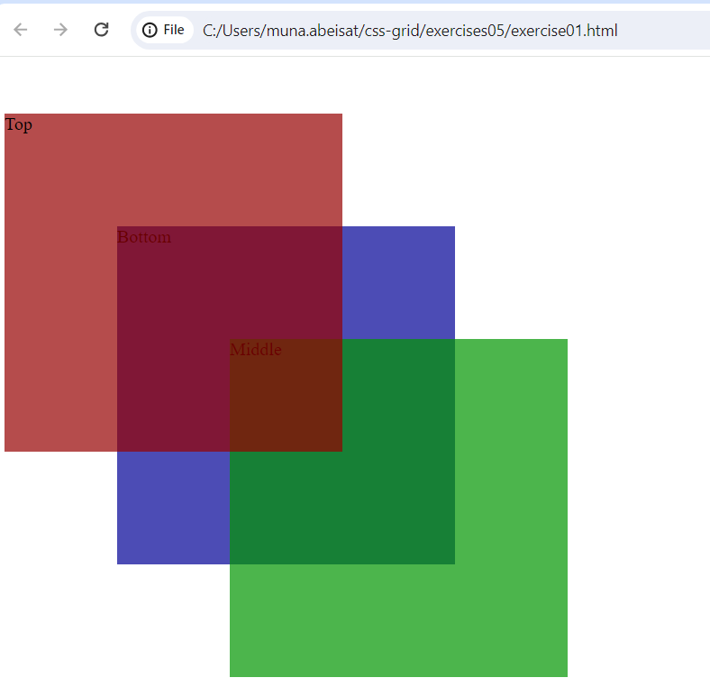

**10.Create card using grid**

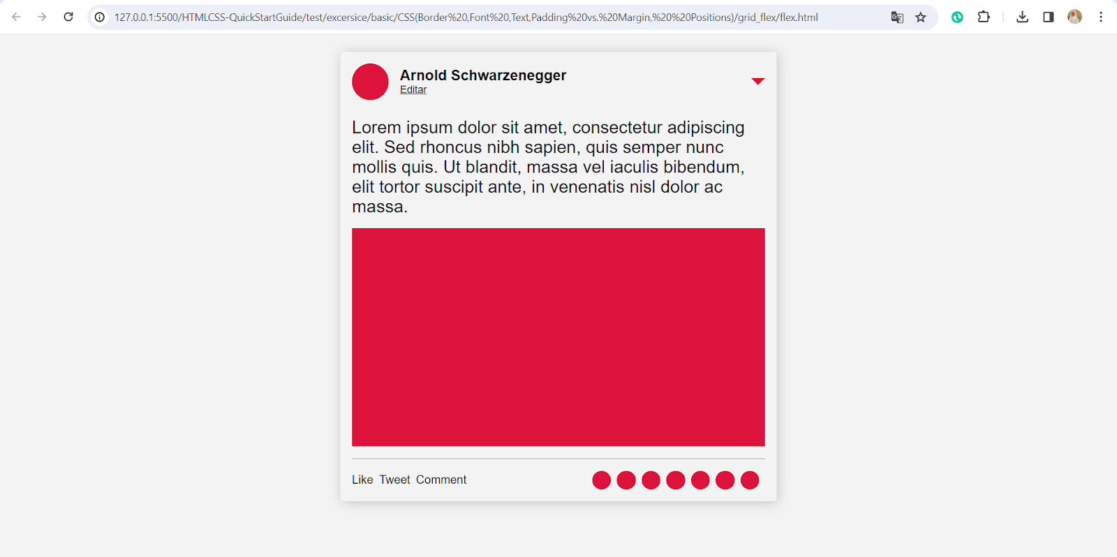

**Advanced**

**11.Create the following(using Grid):**

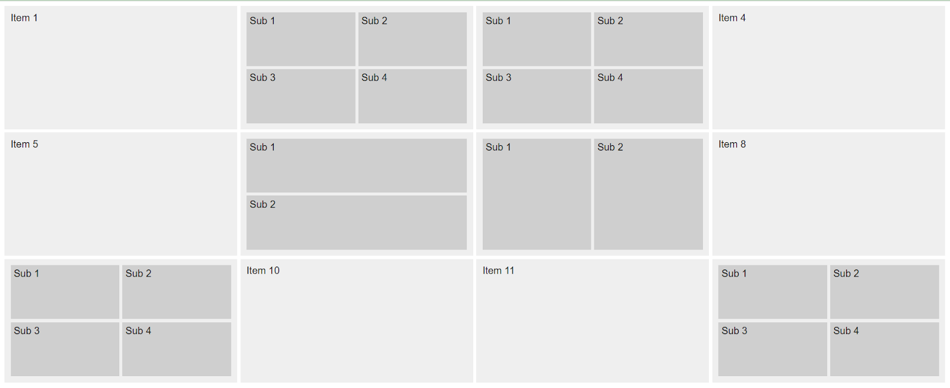

**12. Use CSS grid for the overall layout and Flexbox for the card**

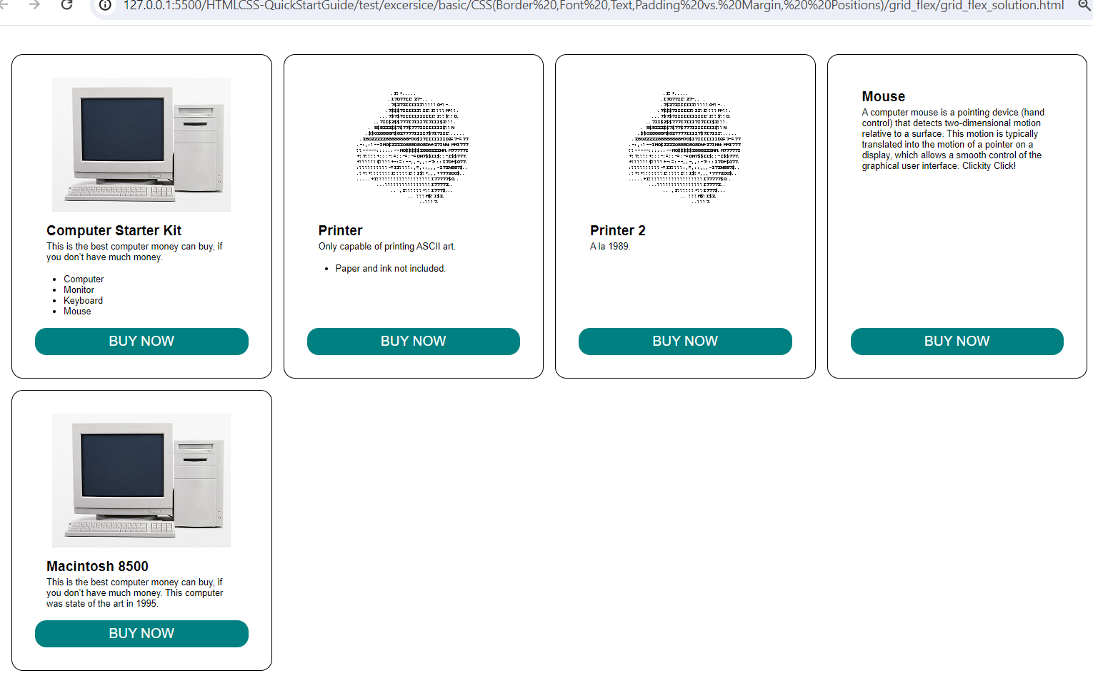

**13.Create the following website:**

[**https://drive.google.com/file/d/1DgBG83cs2zVTalAuCoLvkypoqZlluYGW/view?usp=sharing**](https://drive.google.com/file/d/1DgBG83cs2zVTalAuCoLvkypoqZlluYGW/view?usp=sharing)

**14.Play garden game**

[**https://cssgridgarden.com/**](https://cssgridgarden.com/)